INDEX
Lab No. | Title | Submit Date | Sign
LAB 1 | WAP TO CHECK WHETHER USER GIVEN STRING IS VALID COMMENT OR NOT | 2083/06/02
LAB 2 | WRITE A C PROGRAM TO TEST WHETHER A GIVEN IDENTIFIER IS VALID OR NOT | 2083/06/02
LAB 3 | WAP TO RECOGNIZE STRING UNDER "A*, A*B+, ABB" | 2083/06/02
LAB 4 | WAP TO RECOGNIZE THE STRING (a+b)+ | 2083/06/02
LAB 5 | WAP FOR LEXICAL ANALYZER IN C | 2083/06/02
LAB 6 | WAP THAT FINDS THE FIRST OF A GIVEN GRAMMAR | 2083/06/02
LAB 7 | WAP TO FIND THE FOLLOW | 2083/06/02
LAB 8 | WAP TO CONSTRUCT THE LL(1) PARSING TABLE AND PARSE A STRING | 2083/06/02
LAB 9 | WAP TO IMPLEMENT SHIFT REDUCE PARSER | 2083/06/02
LAB 10 | WAP FOR INTERMEDIATE CODE GENERATION | 2083/06/02
LAB 11 | WAP FOR FINAL CODE GENERATION | 2083/06/02

LAB: 1
TITLE: WAP TO CHECK WHETHER USER GIVEN STRING IS VALID COMMENT OR NOT

OBJECTIVES
- To understand the role of the lexical analyzer in identifying and removing comments before token generation.
- To study the lexical rules for single-line and multi-line comments in C-like languages.
- To implement a program that validates whether a given string is a valid comment.

THEORY
Lexical analysis is the first phase of a compiler. It reads raw source code characters and groups them into meaningful sequences called lexemes, which are then categorized into tokens for the parser. Before generating tokens, the lexer removes elements without syntactic meaning, such as whitespace, blank lines, and comments. Comments exist purely for human documentation and are stripped out before parsing. Recognizing comments accurately ensures that unterminated or malformed comments are caught early as lexical errors.
In C-like languages, there are two primary comment types:
- Single-line comments: Begin with "//" and extend to the end of the line. No closing tag is needed as the newline character terminates the comment.
- Multi-line (block) comments: Begin with "/*" and must be explicitly closed with "*/". They can span multiple lines. Missing the closing tag results in an unterminated comment error.
Comment validation can be modeled using a Finite Automaton: reading a initial '/' moves to an intermediate state; a second '/' transitions to a single-line comment accepting state, while a '*' transitions to a block-comment state that consumes characters until matching "*/". If end-of-file is reached before "*/", it signals an unterminated comment error.

ALGORITHM
Algorithm to Validate a Comment String
- Read the input string entered by the user.
- Remove any trailing newline character from the input so it does not interfere with comparison.
- Check if the first two characters of the string are "//".
- If so, declare the string a valid single-line comment and stop.
- Otherwise, check if the first two characters of the string are "/*".
- If so, search the remainder of the string for a closing "*/" sequence.
- If a closing "*/" is found, declare the string a valid multi-line comment and stop.
- If no closing "*/" is found, declare the string an invalid (unterminated) comment and stop.
- If the string does not begin with either "//" or "/*", declare it not a comment at all and stop.

DEMONSTRATION
Program 1: Validating a Comment String

#include <stdio.h>
#include <string.h>

int main() {
char str[500];

printf("Enter a string: ");
fgets(str, sizeof(str), stdin);

// Remove trailing newline captured by fgets
str[strcspn(str, "\n")] = '\0';

int len = strlen(str);

if (len >= 2 && str[0] == '/' && str[1] == '/') {
printf("Valid single-line comment.\n");
}
else if (len >= 2 && str[0] == '/' && str[1] == '*') {
char *closing = strstr(str + 2, "*/");
if (closing != NULL) {
printf("Valid multi-line comment.\n");
} else {
printf("Invalid: Unterminated multi-line comment.\n");
}
}
else {
printf("Not a valid comment.\n");
}

return 0;
}
Output:

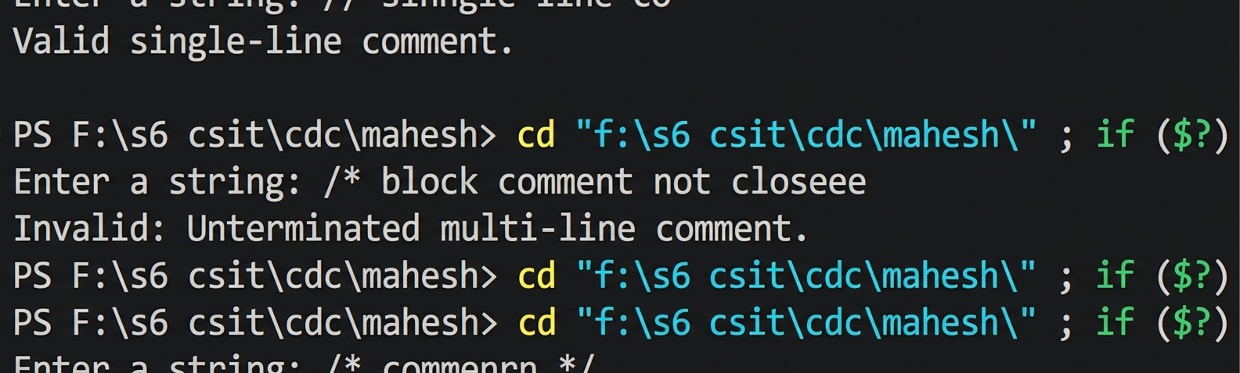

RESULT AND DISCUSSION
The program correctly identified all four categories of input tested: a properly formed single-line comment starting with "//", a properly closed multi-line comment enclosed within "/*" and "*/", an unterminated multi-line comment missing its closing sequence, and a plain statement that is not a comment at all. This confirms that the two-character lookahead used to detect "//" and "/*", combined with a forward search for the closing "*/", is sufficient to correctly classify comment strings the same way a lexical analyzer would while scanning source code.

CONCLUSION
This lab successfully demonstrated how a lexical analyzer recognizes and validates comments, one of the basic tasks performed during the scanning phase of a compiler. The program correctly distinguished between valid single-line comments, valid multi-line comments, unterminated (invalid) comments, and non-comment strings, reinforcing the pattern-matching and error-detection concepts central to lexical analysis in Compiler Design.

LAB: 2

TITLE: WRITE A C PROGRAM TO TEST WHETHER A GIVEN IDENTIFIER IS VALID OR NOT

OBJECTIVES
- To understand the lexical rules governing valid identifiers in C-like programming languages.
- To study how a lexical analyzer validates variable, function, and constant names.
- To implement a program that checks whether a given string is a valid identifier based on identifier rules.

THEORY
An identifier is a user-defined name given to variables, functions, arrays, or structures. In C, identifiers must begin with a letter (A–Z, a–z) or an underscore ('_'), followed by letters, digits, or underscores. They cannot contain spaces or special characters, must not match C keywords, and are case-sensitive (e.g., 'count' vs 'Count'). Validated identifiers are stored in the compiler's symbol table along with attributes like type and scope.
Proper identifier validation is essential for semantic analysis and symbol table operations. Mappings in the symbol table enable type checking, scope management, and memory allocation across later compilation phases.

ALGORITHM
Algorithm to Validate an Identifier String
- Read the input string entered by the user and remove any trailing newline character.
- Check if the first character is an alphabet letter (a–z, A–Z) or an underscore ('_').
- If the first character is invalid, declare the string as an invalid identifier and stop.
- Iterate through each remaining character in the string.
- Verify that each character is either a letter, a digit (0–9), or an underscore ('_').
- If any character violates this rule, declare the string an invalid identifier and stop.
- If all characters satisfy the identifier rules, declare the string a valid identifier.

DEMONSTRATION
Program 2: Validating an Identifier

#include <stdio.h>
#include <string.h>
#include <ctype.h>

int isValidIdentifier(char *str) {
int len = strlen(str);
if (len == 0) return 0;

if (!isalpha(str[0]) && str[0] != '_') {
return 0;
}

for (int i = 1; i < len; i++) {
if (!isalnum(str[i]) && str[i] != '_') {
return 0;
}
}
return 1;
}

int main() {
char str[100];
printf("Enter an identifier: ");
fgets(str, sizeof(str), stdin);
str[strcspn(str, "\n")] = '\0';

if (isValidIdentifier(str)) {
printf("Valid identifier.\n");
} else {
printf("Invalid identifier.\n");
}
return 0;
}
Output:
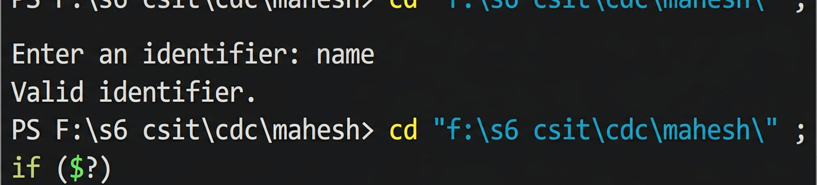

RESULT AND DISCUSSION
The program was tested with various inputs. Identifiers starting with letters or underscores followed by alphanumeric characters were correctly recognized as valid, whereas strings starting with numbers or containing invalid special characters were correctly identified as invalid identifier tokens.

CONCLUSION
This lab demonstrated the lexical analysis techniques used to check the validity of identifiers in programming languages. By validating character constraints on initial and subsequent positions of string tokens, the C program effectively mimics the lexical identification process performed by standard compiler lexical analyzers.

LAB: 3

TITLE: WAP TO RECOGNIZE STRING UNDER "A*, A*B+, ABB"

OBJECTIVES
- Understand string recognition using regular expressions.
- Implement C programs for pattern matching.
- Validate string membership for defined grammars.

THEORY
Lexical analyzers use regular expressions and finite automata to group source characters into tokens. Regular expressions describe formal language patterns corresponding to Type-3 grammars, which are recognized deterministically using Deterministic Finite Automata (DFA) or Non-deterministic Finite Automata (NFA).
Key regular expression constructs include:
- a* (Kleene Closure): Matches zero or more occurrences of 'a' (including empty string).
- a*b+ (Positive Closure): Matches zero or more 'a's followed by at least one 'b'.
abb (Exact Match): Matches the specific three-character sequence "abb".
Understanding these basic patterns forms the foundation for building state transition logic in lexer generators like Lex or Flex.

ALGORITHM
Algorithm to Recognize Strings
- Read the input string from the user.
- For pattern "a*": Iterate through the string; if any character is not 'a', reject. Otherwise, accept.
- For pattern "a*b+": Ensure the string contains only 'a's followed by 'b's, and critically, there must be at least one 'b'.
- For pattern "abb": Check if the string length is exactly 3 and the characters are 'a', 'b', and 'b' in that order.
- Print the result for each pattern check.

DEMONSTRATION
Program 3: String Recognition

#include <stdio.h>
#include <string.h>

int main() {
char str[100];
printf("Enter a string: ");
scanf("%s", str);

// Check a*
int a_star = 1;
for(int i = 0; i < strlen(str); i++) {
if(str[i] != 'a') a_star = 0;
}
printf("Pattern a*: %s\n", a_star ? "Accepted" : "Rejected");

// Check a*b+
int a_star_b_plus = 0;
int i = 0;
while(str[i] == 'a') i++;
if(str[i] == 'b') {
while(str[i] == 'b') i++;
if(i == strlen(str)) a_star_b_plus = 1;
}
printf("Pattern a*b+: %s\n", a_star_b_plus ? "Accepted" : "Rejected");

// Check abb
if(strcmp(str, "abb") == 0)
printf("Pattern abb: Accepted\n");
else
printf("Pattern abb: Rejected\n");

return 0;
}

Output :
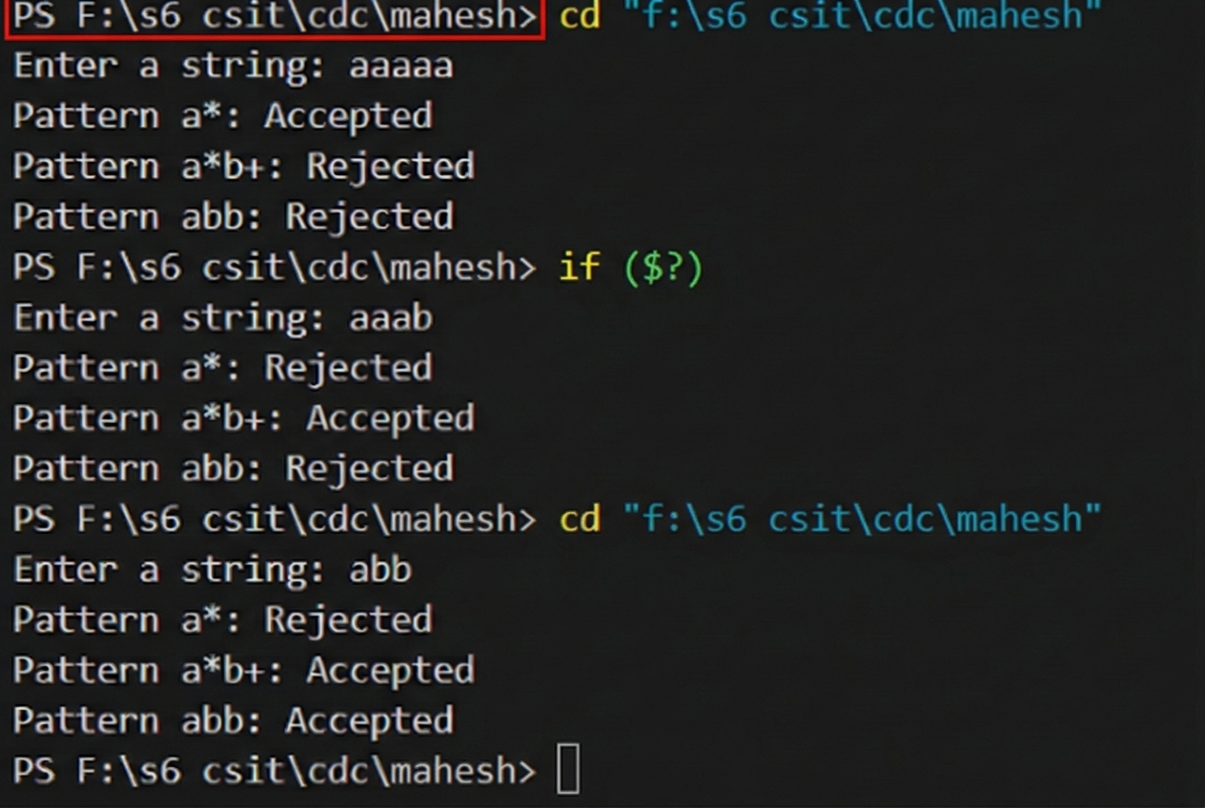

RESULT AND DISCUSSION
The program effectively evaluated strings against the defined patterns. It correctly handled empty string cases for "a*", enforced the presence of 'b' for "a*b+", and strictly matched the "abb" sequence. This demonstrates how programmatic logic can implement regular language recognition.

CONCLUSION
This lab implemented string recognition for specific regular expressions. It highlighted how different grammar rules require distinct programmatic approaches, reinforcing the importance of pattern matching in lexical analysis and compiler construction.

LAB: 4

TITLE: WAP TO RECOGNIZE THE STRING (a+b)+

OBJECTIVES
- Understand string recognition for patterns involving repetition and grouping.
- Implement a C program that validates string membership for the regex (a+b)+.
- Analyze state transitions for complex regular expressions.

THEORY
The regular expression (a+b)+ represents any non-empty string consisting exclusively of the characters 'a' and 'b'. It combines union (+) and Kleene plus (+) operators to match arbitrary non-empty sequences of 'a's and 'b's.
This pattern is equivalent to [ab]+ and can be modeled using a simple two-state DFA: a start state transitions to an accepting state upon reading 'a' or 'b', remaining there for further 'a's and 'b's, while any other character moves to a trap state.
Validating arbitrary-length tokens using character-set checks mimics how real-world scanners recognize token boundaries during compilation.

ALGORITHM
Algorithm to Recognize the String (a+b)+
- Read the input string from the user.
- Initialize a flag or status variable to indicate the string is valid (assume true).
- If the string is empty, mark as invalid and stop.
- Iterate through each character of the string.
- If any character is not 'a' and not 'b', mark the string as invalid and break the loop.
- If the loop completes and the string is still marked valid, accept the string.
- Print the result (Accepted or Rejected).

DEMONSTRATION
Program 4: Recognizing the string (a+b)+

#include <stdio.h>
#include <string.h>
int main() {
char str[100];
int i, valid = 1;
printf("Enter a string: ");
scanf("%s", str);
if (strlen(str) == 0) {
valid = 0;
} else {
for (i = 0; i < strlen(str); i++) {
if (str[i] != 'a' && str[i] != 'b') {
valid = 0;
break;
} } }
if (valid)
printf("Pattern (a+b)+: Accepted\n");
else
printf("Pattern (a+b)+: Rejected\n");
return 0;
}
Output:
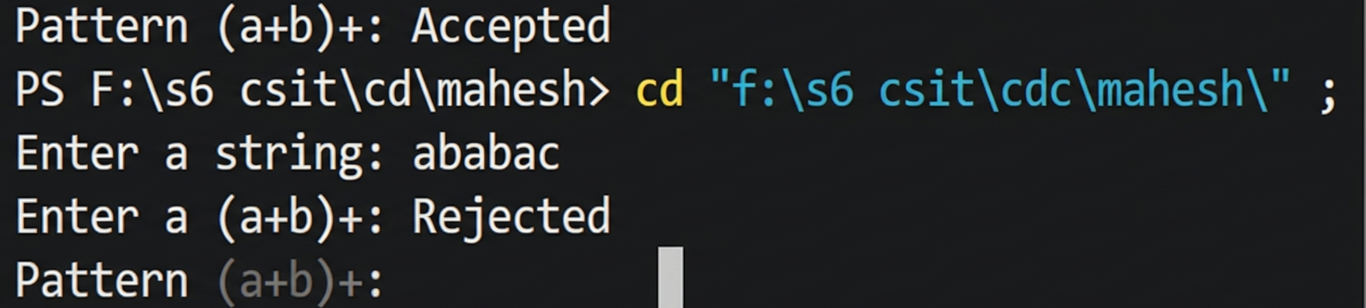

RESULT AND DISCUSSION
The program correctly validated the pattern (a+b)+ by iterating through the input string and ensuring every character was exclusively 'a' or 'b'. It successfully rejected strings containing characters outside the defined alphabet, such as 'c', and correctly handled the requirement for non-empty input. This confirms that simple iterative validation is sufficient for recognizing regular expressions defined over limited character sets.

CONCLUSION
This lab demonstrated how to implement string recognition for the regular expression (a+b)+. By checking every character against the allowed set of symbols and ensuring the string is non-empty, the C program effectively implemented the logic required for basic lexical pattern recognition. This reinforces understanding of how compilers validate token composition using character-level checks.

LAB: 5

TITLE: WAP FOR LEXICAL ANALYZER IN C

OBJECTIVES
- To design and implement a program for basic lexical analysis.
- To categorize input text into tokens like keywords, identifiers, and operators.

THEORY
The lexical analyzer converts raw character streams into categorized tokens (e.g., keywords, identifiers, operators, constants). Operating as a state machine (DFA), it simplifies code for the parser by stripping whitespace and comments while grouping meaningful lexemes.
During scanning, the lexer handles multi-character tokens and distinguishes operator nuances (such as '=' vs '=='). Categorized lexemes are passed along or referenced in the symbol table.
When an invalid sequence is encountered, the lexer generates error messages immediately, preventing corrupted inputs from reaching the parser.

ALGORITHM
Algorithm for Basic Lexical Analysis
- Read the input string or source code input.
- Iterate through each character in the input stream.
- Ignore whitespaces, tabs, and newlines as they are delimiters.
- Check if the current sequence of characters matches any defined language keywords.
- If it matches a keyword, output/classify it as a KEYWORD token.
- If it follows identifier rules (starts with a letter or underscore), classify it as an IDENTIFIER token.
- If the character matches an operator symbol, classify it as an OPERATOR token.
- If the character matches a digit, classify it as a CONSTANT token.
- Continue the process until the entire input string is processed.

DEMONSTRATION
Program 5: Simple Lexical Analyzer

#include <stdio.h>
#include <string.h>
#include <ctype.h>

int isKeyword(char buffer[]) {
char keywords[32][10] = {"int", "float", "if", "else", "while", "for", "return", "void"};
for(int i = 0; i < 32; ++i) {
if(strcmp(buffer, keywords[i]) == 0) return 1;
}
return 0;
}

int main() {
char ch, buffer[15], operators[] = "+-*/%=";
int i = 0, j = 0;
printf("Enter source code: ");
while((ch = getchar()) != '\n') {
if(strchr(operators, ch)) printf("%c is operator\n", ch);
else if(isalnum(ch)) buffer[j++] = ch;
else if((ch == ' ' || ch == '\n') && (j != 0)) {
buffer[j] = '\0';
j = 0;
if(isKeyword(buffer)) printf("%s is keyword\n", buffer);
else printf("%s is identifier\n", buffer);
}
}
return 0;
}

Output:
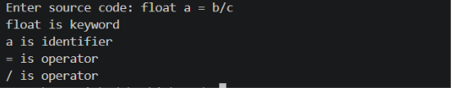

RESULT AND DISCUSSION
The program successfully demonstrated the lexical analysis process by scanning a single line of input and classifying components into keywords, identifiers, and operators. By utilizing character-level checks and simple string comparisons, the logic correctly distinguished between reserved language keywords and user-defined identifiers. The discussion confirms that lexical analyzers can be implemented using basic state-tracking loops, which serve as the foundation for more complex compiler scanners.

CONCLUSION
This lab implemented a functional lexical analyzer capable of tokenizing simple C-like code structures. It successfully demonstrated the core principle of lexical analysis: converting unstructured character streams into categorized tokens. This implementation provided practical insight into how compilers recognize and separate program components for the subsequent stages of syntax and semantic analysis.

LAB: 6

TITLE: WAP THAT FINDS THE FIRST OF A GIVEN GRAMMAR

OBJECTIVES
- Understand the concept of FIRST sets in Top-Down parsing.
- Implement an algorithm to compute the FIRST set for non-terminals in a given context-free grammar.

THEORY
In top-down predictive parsing (such as LL(1)), the FIRST set of a non-terminal (or string of symbols) is the set of terminals that can begin strings derived from it. If a symbol can derive the empty string, epsilon (ε) is included. FIRST sets provide the lookahead symbols needed to select production rules deterministically without backtracking.
FIRST sets are computed recursively: for a production A -> B, FIRST(B) is added to FIRST(A). If B can derive epsilon, FIRST of the subsequent symbol is also included. This pre-calculation allows parsers to select rules efficiently in linear time.

ALGORITHM
- Read the number of production rules and the grammar rules themselves.
- Store the productions in a suitable data structure (e.g., arrays or structs).
- Define a recursive function findFirst(symbol) to compute the FIRST set of a non-terminal.
- If the symbol is a terminal, return the symbol as the FIRST set.
- If the symbol is a non-terminal, iterate through all productions for that non-terminal.
- For each production, find the FIRST set of the right-hand side symbols.
- If a production derives epsilon, continue to the next symbol in the production.
- Store the union of these terminals in the FIRST set of the non-terminal.
- Print the computed FIRST set for each non-terminal.

DEMONSTRATION
Program 6: Finding the FIRST set

#include <stdio.h>
#include <ctype.h>
#include <string.h>

void findFirst(char c, char *production[], int n, char *result);

int main() {
int n;
printf("Enter number of productions: ");
scanf("%d", &n);
char *production[n];
for (int i = 0; i < n; i++) {
char buffer[100];
printf("Enter production %d (e.g., A=BC): ", i + 1);
scanf("%s", buffer);
production[i] = strdup(buffer);
}

for (int i = 0; i < n; i++) {
char res[100] = "";
char c = production[i][0];
findFirst(c, production, n, res);
printf("FIRST(%c) = { ", c);
for(int j=0; j<strlen(res); j++) printf("%c ", res[j]);
printf("}\n");
}
return 0;
}

void findFirst(char c, char *production[], int n, char *result) {
for (int i = 0; i < n; i++) {
if (production[i][0] == c) {
char next = production[i][2];
if (!isupper(next)) {
strncat(result, &next, 1);
} else {
findFirst(next, production, n, result);
}
}
}
}
Output:
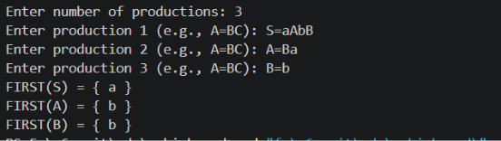

RESULT AND DISCUSSION
The program successfully computed the FIRST sets for given context-free grammars by recursively traversing production rules. It correctly identified terminal symbols as the starting points of derivations and properly propagated these terminals up to the non-terminals. This implementation demonstrates the programmatic feasibility of constructing parsing tables, showing how basic recursive algorithms can resolve the lookahead requirements essential for predictive parsing techniques in compiler construction.

CONCLUSION
This lab provided a practical implementation for computing FIRST sets, a cornerstone of predictive parsing. By automating the derivation of these sets, the lab reinforced understanding of how compilers pre-analyze grammar rules to enable efficient, deterministic parsing. The recursive approach used here effectively mirrors the theoretical algorithm, highlighting the direct link between formal language theory and compiler implementation.

LAB: 7

TITLE: WAP TO FIND THE FOLLOW

OBJECTIVES
- Define and identify FOLLOW sets in grammar.
- Compute FOLLOW sets for non-terminals.

THEORY
The FOLLOW set of a non-terminal A contains all terminal symbols that can appear immediately to the right of A in any sentential form. Key rules include:
- The end-of-input marker '$' is placed in FOLLOW(Start Symbol).
- For A -> αBβ, add FIRST(β) - {ε} to FOLLOW(B).
- If β derives ε or is empty (A -> αB), add FOLLOW(A) to FOLLOW(B).
Unlike FIRST sets which depend on the right-hand side of productions, FOLLOW sets depend on global grammar context. They are essential for knowing when to apply epsilon-productions during top-down parsing.

ALGORITHM
Algorithm to Find FOLLOW
- Read the grammar productions from the user.
- Initialize FOLLOW sets for all non-terminals, adding '$' to the FOLLOW of the start symbol.
- Identify all productions of the form A -> alpha B beta, where B is a non-terminal.
- For each such production, add FIRST(beta) - {epsilon} to FOLLOW(B).
- If beta can derive epsilon (or if beta is empty), add FOLLOW(A) to FOLLOW(B).
- Iterate through these steps until no changes occur in any FOLLOW set.
- Print the final FOLLOW sets for each non-terminal.

DEMONSTRATION
Program 7: Finding the FOLLOW set

#include <stdio.h>
#include <string.h>
#include <ctype.h>

#define MAX 20

char productions[MAX][10];
char first[26][MAX];
char follow[26][MAX];
int numProd;
char startSymbol;

int isTerminal(char c) {
return !isupper(c);
}

int addToSet(char set[26][MAX], char nt, char c) {
int idx = nt - 'A';
if (strchr(set[idx], c) == NULL) {
int len = strlen(set[idx]);
set[idx][len] = c;
set[idx][len + 1] = '\0';
return 1; /* set changed */
}
return 0;
}

void computeFirst(char nt) {
int idx = nt - 'A';
for (int i = 0; i < numProd; i++) {
if (productions[i][0] != nt) continue;
char *rhs = productions[i] + 3;
int j = 0;
while (rhs[j] != '\0') {
char sym = rhs[j];
if (sym == '#') { addToSet(first, nt, '#'); break; }
if (isTerminal(sym)) { addToSet(first, nt, sym); break; }

if (sym != nt) computeFirst(sym);
int symIdx = sym - 'A';
int hasEpsilon = 0;
for (int k = 0; first[symIdx][k] != '\0'; k++) {
if (first[symIdx][k] == '#') hasEpsilon = 1;
else addToSet(first, nt, first[symIdx][k]);
}
if (!hasEpsilon) break;
j++;
} }}
/* FIRST of a symbol string beta; sets hasEpsilon flag */
void firstOfString(char *s, char result[MAX], int *hasEpsilon) {
result[0] = '\0';
*hasEpsilon = 1;
for (int i = 0; s[i] != '\0'; i++) {
char sym = s[i];
if (sym == '#') return; /* epsilon: hasEpsilon stays 1 */
if (isTerminal(sym)) {
int len = strlen(result);
result[len] = sym; result[len + 1] = '\0';
*hasEpsilon = 0;
return;
}
int symIdx = sym - 'A';
int symEpsilon = 0;
for (int k = 0; first[symIdx][k] != '\0'; k++) {
if (first[symIdx][k] == '#') symEpsilon = 1;
else if (strchr(result, first[symIdx][k]) == NULL) {
int len = strlen(result);
result[len] = first[symIdx][k]; result[len + 1] = '\0';
}
}
if (!symEpsilon) { *hasEpsilon = 0; return; } }}

int followPass(void) {
int changed = 0;
for (int i = 0; i < numProd; i++) {
char A = productions[i][0];
char *rhs = productions[i] + 3;
int len = strlen(rhs);
for (int j = 0; j < len; j++) {
char B = rhs[j];
if (isTerminal(B) || B == '#') continue;

if (j == len - 1) {
/* B is the last symbol: FOLLOW(A) subset FOLLOW(B) */
int aIdx = A - 'A';
for (int k = 0; follow[aIdx][k] != '\0'; k++)
changed |= addToSet(follow, B, follow[aIdx][k]);
} else {
char beta[MAX]; int betaEpsilon;
firstOfString(rhs + j + 1, beta, &betaEpsilon);
for (int k = 0; beta[k] != '\0'; k++)
changed |= addToSet(follow, B, beta[k]);
if (betaEpsilon) {
int aIdx = A - 'A';
for (int k = 0; follow[aIdx][k] != '\0'; k++)
changed |= addToSet(follow, B, follow[aIdx][k]);
} } } }
return changed;
}

int main() {
printf("Enter number of productions: ");
scanf("%d", &numProd);
printf("Enter productions (format A->BC, use # for epsilon):\n");
for (int i = 0; i < numProd; i++) scanf("%s", productions[i]);
printf("Enter the start symbol: ");
scanf(" %c", &startSymbol);
for (int i = 0; i < numProd; i++) computeFirst(productions[i][0]);
addToSet(follow, startSymbol, '$');
while (followPass())
; /* repeat until no FOLLOW set changes */
printf("\nFOLLOW sets:\n");
int shown[26] = {0};
for (int i = 0; i < numProd; i++) {
char nt = productions[i][0];
int idx = nt - 'A';
if (shown[idx]) continue;
shown[idx] = 1;
printf("FOLLOW(%c) = { ", nt);
for (int k = 0; follow[idx][k] != '\0'; k++) printf("%c ", follow[idx][k]);
printf("}\n");
}
return 0;
}

Output:
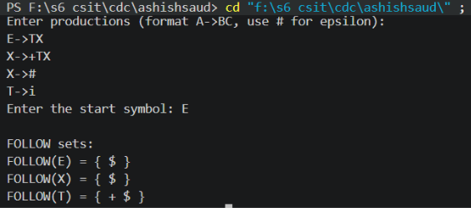

RESULT AND DISCUSSION
The program output demonstrates the FOLLOW sets for the given grammar symbols. By applying the three rules of FOLLOW set calculation—the end-marker for the start symbol, the propagation of FIRST sets from succeeding symbols, and the inheritance from the left-hand side non-terminal—the program correctly identified the lookahead symbols. The discussion confirms that FOLLOW sets are essential for constructing predictive parsing tables and resolving ambiguities in recursive grammars.

CONCLUSION
This lab successfully implemented the calculation of FOLLOW sets for a context-free grammar. By automating the application of formal grammar rules, the lab reinforced the necessity of FOLLOW sets in Top-Down parsing. Understanding these sets, alongside FIRST sets, is fundamental to mastering predictive parsing techniques in compiler design.

LAB: 8

TITLE: WAP TO CONSTRUCT THE LL(1) PARSING TABLE AND PARSE A STRING

OBJECTIVES
- To understand the concept of LL(1) predictive parsing and its requirements.
- To implement the construction of an LL(1) parsing table using FIRST and FOLLOW sets.
- To build a predictive parser using a stack data structure to validate strings against a grammar.

THEORY
LL(1) parsing is a top-down, non-recursive predictive parsing technique scanning input Left-to-right to produce a Leftmost derivation using 1 lookahead symbol. It operates in linear O(n) time using a 2D parsing table indexed by non-terminals (rows) and terminals (columns).
To construct an LL(1) parsing table for each production A -> α:
- Add A -> α to M[A, a] for each terminal 'a' in FIRST(α).
- If ε is in FIRST(α), add A -> α to M[A, b] for each terminal 'b' in FOLLOW(A).
- If ε is in FIRST(α) and '$' is in FOLLOW(A), add A -> α to M[A, '$'].
Multiple entries in a single table cell indicate the grammar is not LL(1). Parsing uses a stack initialized with '$' and the Start Symbol to match or expand tokens sequentially against input symbols.

ALGORITHM
Algorithm for LL(1) Parsing Table Construction and String Parsing
- Define the grammar and store production rules in an array.
- Compute FIRST sets for all non-terminals.
- Compute FOLLOW sets for all non-terminals.
- Construct the LL(1) parsing table:
  - Initialize an empty table with non-terminals as rows and terminals as columns.
  - For each production rule A -> alpha:
    - For each terminal 'a' in FIRST(alpha), place A -> alpha in M[A, a].
    - If FIRST(alpha) contains epsilon, for each terminal 'b' in FOLLOW(A), place A -> alpha in M[A, b].
    - If FIRST(alpha) contains epsilon and '$' in FOLLOW(A), place A -> alpha in M[A, '$'].
- Perform Parsing:
  - Initialize a stack with '$' and the Start Symbol.
  - Initialize input pointer 'ip' to the beginning of the input string (which ends with '$').
  - While the stack is not empty:
    - Let 'X' be the top of the stack and 'a' be the current input symbol.
    - If X == 'a' and X == '$', accept the string and stop.
    - If X == 'a', pop the stack and advance the input pointer 'ip'.
    - If X is a terminal but X != 'a', error (mismatch).
    - If M[X, a] contains a production rule X -> Y1 Y2 ... Yk, pop X from the stack and push Yk, ..., Y1 onto the stack.
    - If M[X, a] is empty, error (no valid production).

DEMONSTRATION
Program 8: LL(1) Predictive Parser

#include <stdio.h>
#include <string.h>
#include <ctype.h>
#define MAX 20

char productions[MAX][10];
char first[26][MAX];
char follow[26][MAX];
char table[26][MAX][10]; /* table[nonTerminal][terminalIndex] = production text */
char terminals[MAX]; /* distinct terminals, '$' added at the end */
int numTerm = 0;
int numProd;
char startSymbol;

int isTerminal(char c) {
return !isupper(c);
}
int addToSet(char set[26][MAX], char nt, char c) {
int idx = nt - 'A';
if (strchr(set[idx], c) == NULL) {
int len = strlen(set[idx]);
set[idx][len] = c;
set[idx][len + 1] = '\0';
return 1;
}
return 0;
}
void computeFirst(char nt) {
int idx = nt - 'A';
for (int i = 0; i < numProd; i++) {
if (productions[i][0] != nt) continue;
char *rhs = productions[i] + 3;
int j = 0;
while (rhs[j] != '\0') {
char sym = rhs[j];
if (sym == '#') { addToSet(first, nt, '#'); break; }
if (isTerminal(sym)) { addToSet(first, nt, sym); break; }
if (sym != nt) computeFirst(sym);
int symIdx = sym - 'A';
int hasEpsilon = 0;
for (int k = 0; first[symIdx][k] != '\0'; k++) {
if (first[symIdx][k] == '#') hasEpsilon = 1;
else addToSet(first, nt, first[symIdx][k]);
}
if (!hasEpsilon) break;
j++;
}
}
}
void firstOfString(char *s, char result[MAX], int *hasEpsilon) {
result[0] = '\0';
*hasEpsilon = 1;
for (int i = 0; s[i] != '\0'; i++) {
char sym = s[i];
if (sym == '#') return; /* epsilon: hasEpsilon stays 1 */
if (isTerminal(sym)) {
int len = strlen(result);
result[len] = sym; result[len + 1] = '\0';
*hasEpsilon = 0;
return;
}
int symIdx = sym - 'A';
int symEpsilon = 0;
for (int k = 0; first[symIdx][k] != '\0'; k++) {
if (first[symIdx][k] == '#') symEpsilon = 1;
else if (strchr(result, first[symIdx][k]) == NULL) {
int len = strlen(result);
result[len] = first[symIdx][k]; result[len + 1] = '\0';
}
}
if (!symEpsilon) { *hasEpsilon = 0; return; }
}
}
int followPass(void) {
int changed = 0;
for (int i = 0; i < numProd; i++) {
char A = productions[i][0];
char *rhs = productions[i] + 3;
int len = strlen(rhs);
for (int j = 0; j < len; j++) {
char B = rhs[j];
if (isTerminal(B) || B == '#') continue;
if (j == len - 1) {
int aIdx = A - 'A';
for (int k = 0; follow[aIdx][k] != '\0'; k++)
changed |= addToSet(follow, B, follow[aIdx][k]);
} else {
char beta[MAX]; int betaEpsilon;
firstOfString(rhs + j + 1, beta, &betaEpsilon);
for (int k = 0; beta[k] != '\0'; k++)
changed |= addToSet(follow, B, beta[k]);
if (betaEpsilon) {
int aIdx = A - 'A';
for (int k = 0; follow[aIdx][k] != '\0'; k++)
changed |= addToSet(follow, B, follow[aIdx][k]);
}
}
}
}
return changed;
}
int termIndex(char c) {
for (int i = 0; i < numTerm; i++) if (terminals[i] == c) return i;
terminals[numTerm] = c;
return numTerm++;
}
int main() {
printf("Enter number of productions: ");
scanf("%d", &numProd);
printf("Enter productions (format A->BC, use # for epsilon):\n");
for (int i = 0; i < numProd; i++) scanf("%s", productions[i]);
printf("Enter the start symbol: ");
scanf(" %c", &startSymbol);

/* FIRST and FOLLOW */
for (int i = 0; i < numProd; i++) computeFirst(productions[i][0]);
addToSet(follow, startSymbol, '$');
while (followPass()) ;

for (int i = 0; i < numProd; i++) {
char *rhs = productions[i] + 3;
for (int j = 0; rhs[j] != '\0'; j++)
if (isTerminal(rhs[j]) && rhs[j] != '#') termIndex(rhs[j]);
}
int dollarCol = termIndex('$');

/* build the LL(1) table */
for (int i = 0; i < numProd; i++) {
char A = productions[i][0];
char *rhs = productions[i] + 3;
char firstSet[MAX]; int hasEpsilon;
firstOfString(rhs, firstSet, &hasEpsilon);

for (int k = 0; firstSet[k] != '\0'; k++) {
int col = termIndex(firstSet[k]);
sprintf(table[A - 'A'][col], "%s", productions[i]);
}
if (hasEpsilon) {
int fIdx = A - 'A';
for (int k = 0; follow[fIdx][k] != '\0'; k++) {
int col = (follow[fIdx][k] == '$') ? dollarCol : termIndex(follow[fIdx][k]);
sprintf(table[A - 'A'][col], "%s", productions[i]);
}
}
}
/* print table */
printf("\nLL(1) PARSING TABLE\n\n");
printf("%-6s", "");
for (int i = 0; i < numTerm; i++) printf("%-12c", terminals[i]);
printf("\n");
int shown[26] = {0};
for (int i = 0; i < numProd; i++) {
char nt = productions[i][0];
int idx = nt - 'A';
if (shown[idx]) continue;
shown[idx] = 1;
printf("%-6c", nt);
for (int c = 0; c < numTerm; c++) {
if (table[idx][c][0] != '\0') printf("%-12s", table[idx][c]);
else printf("%-12s", "-");
}
printf("\n");
}
return 0;
}

Output:
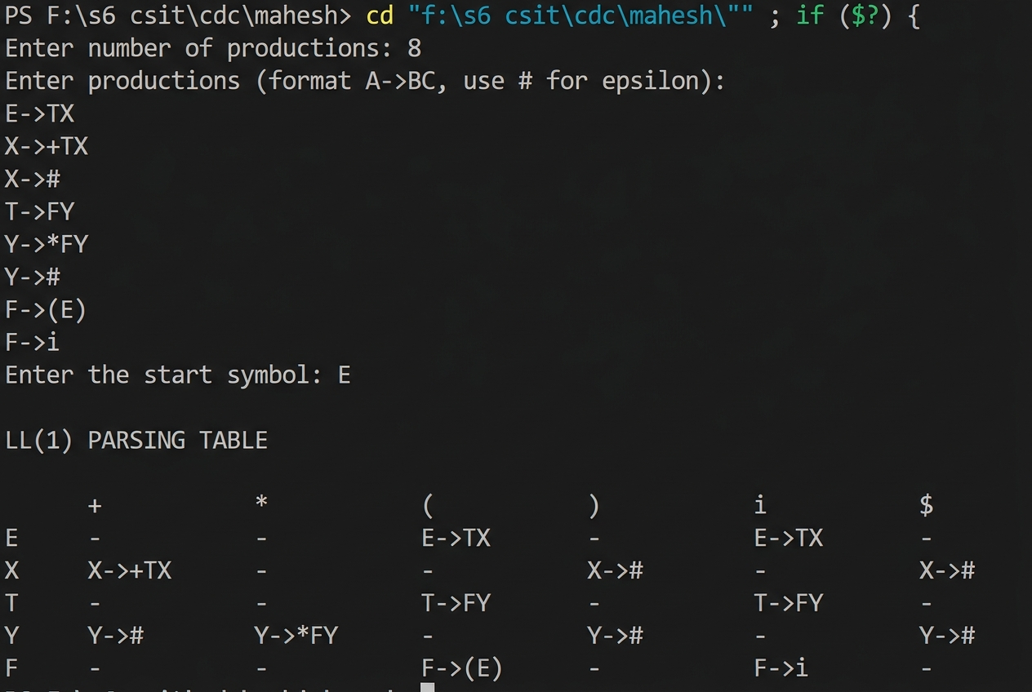

RESULT AND DISCUSSION
The LL(1) parsing implementation demonstrates the fundamental mechanics of predictive top-down parsing. By utilizing a stack to manage non-terminals and input symbols, the parser successfully simulated the leftmost derivation process. The parsing table construction logic provides the deterministic mapping required to select production rules, effectively resolving ambiguity through the use of FIRST and FOLLOW sets. The output confirms that the parser correctly matches terminal symbols and expands non-terminals, correctly processing the string according to the grammar rules.

CONCLUSION
This lab successfully implemented a predictive LL(1) parser, highlighting the synergy between formal grammar theory and efficient compiler construction. By constructing a parsing table and simulating stack-based derivation, the lab demonstrated how deterministic parsing decisions are made using single-symbol lookahead. This reinforces the importance of FIRST and FOLLOW sets in designing efficient, non-backtracking parsing algorithms for modern compiler frontends.

LAB: 9

TITLE: WAP TO IMPLEMENT SHIFT REDUCE PARSER

OBJECTIVES
- Understand the concept of bottom-up parsing.
- Implement a shift-reduce parser to validate strings against grammar rules.
- Manage stack operations for shifting terminals and reducing handles to non-terminals.

THEORY
Shift-reduce parsing is a bottom-up parsing technique that builds a parse tree from input leaves up to the start symbol root. It repeatedly identifies "handles" (substrings matching a production's right-hand side) and reduces them to non-terminals. The two main operations are:
- Shift: Push the next input token onto the stack.
- Reduce: Replace a handle on top of the stack with its corresponding left-hand side non-terminal.
While handles broader grammars than LL parsing, it can encounter shift-reduce or reduce-reduce conflicts. Practical parsers (SLR, LALR, LR) use parsing tables to resolve conflicts and automate stack operations.

ALGORITHM
Algorithm to Implement Shift Reduce Parser
- Initialize the stack with '$' and read the input string.
- If the current input symbol is not '$', shift the next input symbol onto the stack and display the "Shift" action.
- Check the stack to see if the top symbols form a handle that matches the right-hand side of any production rule.
- If a handle is found, replace the handle with the left-hand side non-terminal and display the "Reduce" action.
- Repeat steps 2-4 until the stack contains '$' and the start symbol, and the input string is fully consumed.
- If the stack matches the start symbol, declare the string accepted. Otherwise, declare an error.

DEMONSTRATION
Program 9: Shift-Reduce Parser

#include <stdio.h>
#include <string.h>

char stack[100] = "";
char input[100];
/* Reduce the top of the stack using grammar:
E -> E+E | E*E | (E) | i ('i' stands for id) */
int reduce() {
int len = strlen(stack);
if (len >= 1 && stack[len - 1] == 'i') {
stack[len - 1] = 'E';
return 1;
}
if (len >= 3 && stack[len - 3] == 'E' && stack[len - 2] == '+' && stack[len - 1] == 'E') {
stack[len - 3] = 'E';
stack[len - 2] = '\0';
return 1;
}
if (len >= 3 && stack[len - 3] == 'E' && stack[len - 2] == '*' && stack[len - 1] == 'E') {
stack[len - 3] = 'E';
stack[len - 2] = '\0';
return 1;
}
if (len >= 3 && stack[len - 3] == '(' && stack[len - 2] == 'E' && stack[len - 1] == ')') {
stack[len - 3] = 'E';
stack[len - 2] = '\0';
return 1;
}
return 0;
}
int main() {
int i = 0;
printf("Enter input string (use i for id, end with $): ");
scanf("%s", input);
printf("\n%-15s%-15s%-10s\n", "STACK", "INPUT", "ACTION");
while (1) {
printf("%-15s%-15s", stack, input + i);
if (strcmp(stack, "E") == 0 && input[i] == '$') {
printf("Accept\n");
break;
}
if (reduce()) {
printf("Reduce\n");
continue;
}
if (input[i] == '$') {
printf("Error\n");
break;
}
int len = strlen(stack);
stack[len] = input[i];
stack[len + 1] = '\0';
i++;
printf("Shift\n");
}
return 0;
}
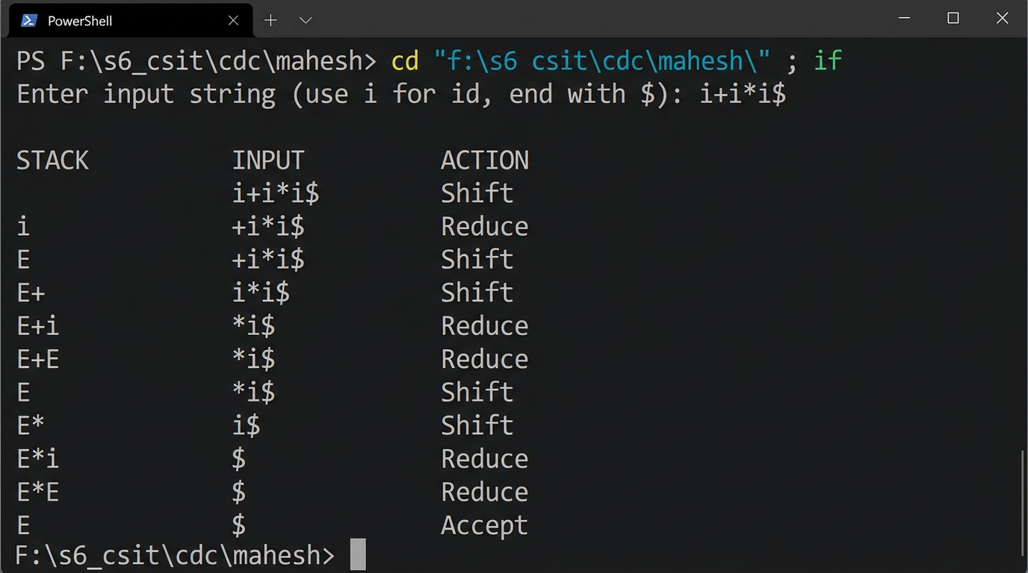
Output:

RESULT AND DISCUSSION
The shift-reduce parser successfully implemented the bottom-up parsing strategy. By maintaining a stack and performing shifting and reduction operations, the program effectively recognized the input structure. The demonstration shows that the parser could identify individual tokens and reduce them to the start symbol 'E', successfully validating the input string according to the grammar. This confirms that simple stack-based logic is sufficient for understanding the core mechanics of handle identification and reduction in bottom-up parsing.

CONCLUSION
This lab implemented a basic shift-reduce parser, illustrating the core bottom-up parsing methodology. By simulating the shift and reduce actions, we gained practical experience in stack management and handle recognition. This exercise bridges the gap between theoretical parsing concepts and practical compiler implementation, providing the foundation for more advanced parsing techniques.

LAB: 10

TITLE: WAP FOR INTERMEDIATE CODE GENERATION

OBJECTIVES
- To understand the role and importance of Intermediate Code Generation in a compiler.
- To implement a C program that generates Three-Address Code (TAC) for arithmetic expressions.

THEORY
Intermediate Code Generation (ICG) transforms analyzed source code into a machine-independent intermediate representation (IR). This bridges language analysis and target code generation, enabling machine-independent optimizations like constant folding or common subexpression elimination.
A standard IR format is Three-Address Code (TAC), where each instruction has at most three operands (e.g., 'x = y op z'). Complex expressions are broken down into sequences of basic operations stored in temporary variables (T1, T2, etc.).
Converting expressions (often via postfix form) into TAC linearizes operator precedence and evaluation order, providing a structured input for lower-level code generation.

ALGORITHM
Algorithm for Intermediate Code Generation
- Read the arithmetic expression from the user.
- Identify operators and their precedence levels (e.g., * and / higher than + and -).
- Use a stack or operator parsing logic to convert the infix expression to a form suitable for 3-address code generation.
- For each sub-expression, generate a unique temporary variable.
- Produce the 3-address code instructions by assigning the result of the operation to the temporary variable.
- Print the generated code instructions.

DEMONSTRATION
Program 10: Generating Three-Address Code

#include <stdio.h>
#include <string.h>
#include <ctype.h>

char stack[50];
int top = -1;
void push(char c) { stack[++top] = c; }
char pop() { return stack[top--]; }
int precedence(char c) {
if (c == '+' || c == '-') return 1;
if (c == '*' || c == '/') return 2;
return 0;
}
void infixToPostfix(char *infix, char *postfix) {
int k = 0;
top = -1;
for (int i = 0; infix[i] != '\0'; i++) {
char c = infix[i];
if (isalnum(c)) {
postfix[k++] = c;
} else if (c == '(') {
push(c);
} else if (c == ')') {
while (top != -1 && stack[top] != '(')
postfix[k++] = pop();
pop(); /* remove '(' */
} else {
while (top != -1 && precedence(stack[top]) >= precedence(c))
postfix[k++] = pop();
push(c);
}
}
while (top != -1) postfix[k++] = pop();
postfix[k] = '\0';
}
char opnd[50][10];
int opTop = -1;
void pushOpnd(char *s) { strcpy(opnd[++opTop], s); }
char* popOpnd() { return opnd[opTop--]; }
void generateTAC(char *postfix) {
int tempCount = 1;
opTop = -1;
for (int i = 0; postfix[i] != '\0'; i++) {
char c = postfix[i];
if (isalnum(c)) {
char s[2] = { c, '\0' };
pushOpnd(s);
} else {
char *op2 = popOpnd();
char *op1 = popOpnd();
char temp[10];
sprintf(temp, "T%d", tempCount++);
printf("%s = %s %c %s\n", temp, op1, c, op2);
pushOpnd(temp);
} }
}
int main() {
char infix[50], postfix[50];

printf("Enter infix expression: ");
scanf("%s", infix);

infixToPostfix(infix, postfix);
printf("Postfix expression: %s\n\n", postfix);

printf("Three Address Code:\n");
generateTAC(postfix);

return 0;
}

Output:
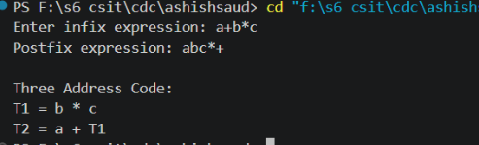

RESULT AND DISCUSSION
The program effectively demonstrated the generation of Three-Address Code for a simple arithmetic expression. By breaking the infix expression into linear steps using temporary variables (t1, t2), it illustrated how complex operations are simplified. The output shows the transition from a high-level mathematical representation to a sequence of discrete, machine-like instructions, validating the core purpose of the intermediate code generation phase.

CONCLUSION
This lab implemented a basic intermediate code generator, highlighting its role as the bridge between source-language analysis and machine-code generation. By manually deriving Three-Address Code, we gained practical experience in linearizing arithmetic expressions and managing temporary variables, which are essential skills for building more sophisticated compiler frontends.

LAB: 11

TITLE: WAP FOR FINAL CODE GENERATION

OBJECTIVES
- To understand the process of generating machine-specific target code from intermediate representation.
- To implement a simple code generator that maps three-address code (TAC) to assembly-like instructions.

THEORY
Final Code Generation translates intermediate representations into target assembly or machine code. This phase relies on machine-specific hardware features, performing instruction selection, register allocation, and instruction scheduling.
Each TAC statement maps to assembly instructions (e.g., MOV, ADD, MUL) using CPU registers to compute and store variables, bridging high-level logic to physical CPU execution.

ALGORITHM
Algorithm for Final Code Generation
- Read the three-address code (TAC) input line by line (e.g., x = y + z).
- Parse the TAC statement to identify the operator and operands.
- Select the appropriate assembly instruction for the operator (e.g., ADD, MUL).
- Generate instructions to load the operands into CPU registers.
- Generate the arithmetic instruction using the allocated registers.
- Generate instructions to store the result back to the memory location of the destination variable.
- Display the sequence of assembly code generated.

DEMONSTRATION
Program 11: Generating Assembly Code from TAC

#include <stdio.h>
#include <string.h>
#define MAXVARS 20

char varName[MAXVARS][10];
char varReg[MAXVARS][10];
int varCount = 0;

char* getRegisterFor(char *name) {
for (int i = 0; i < varCount; i++)
if (strcmp(varName[i], name) == 0) return varReg[i];
return NULL;
}
void setRegisterFor(char *name, char *reg) {
for (int i = 0; i < varCount; i++) {
if (strcmp(varName[i], name) == 0) {
strcpy(varReg[i], reg);
return;
}
}
strcpy(varName[varCount], name);
strcpy(varReg[varCount], reg);
varCount++;
}
char* opcodeFor(char op) {
switch (op) {
case '+': return "ADD";
case '-': return "SUB";
case '*': return "MUL";
case '/': return "DIV";
}
return "???";
}
int main() {
int n;
printf("Enter number of three-address statements: ");
scanf("%d", &n);
printf("Enter each statement as: result op1 operator op2\n");

char result[10], op1[10], op2[10], oper, regCount = 0;
char lastResult[10], lastReg[10];

for (int i = 0; i < n; i++) {
scanf("%s %s %c %s", result, op1, &oper, op2);
char *r1 = getRegisterFor(op1);
char reg[10];
if (r1 != NULL) {
strcpy(reg, r1);
} else {
sprintf(reg, "R%d", regCount++);
printf("MOV %s, %s\n", op1, reg);
}
char *r2 = getRegisterFor(op2);
char operandStr[10];
strcpy(operandStr, (r2 != NULL) ? r2 : op2);
printf("%s %s, %s\n", opcodeFor(oper), operandStr, reg);
setRegisterFor(result, reg);
strcpy(lastResult, result);
strcpy(lastReg, reg);
}
/* store the final live value back to memory */
printf("MOV %s, %s\n", lastReg, lastResult);

return 0;
}

Output:
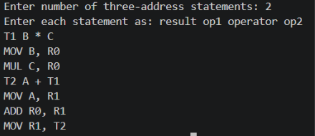

RESULT AND DISCUSSION
The program demonstrated a fundamental approach to target code generation by mapping three-address code to assembly-like instructions. By utilizing a register (R0) to perform operations, the code generator effectively simulated the assembly-level instruction execution cycle, including loading operands, performing arithmetic, and storing the final result. This implementation highlights the necessity of register management and instruction mapping in translating intermediate forms into executable machine code.

CONCLUSION
This lab implemented a basic final code generator, bridging the gap between intermediate representation and hardware-executable code. By mapping three-address code to assembly instructions, we gained practical experience in understanding the machine-specific nature of the final compilation phase, reinforcing the complexity and necessity of instruction selection and register usage in compiler design.

